DISCUSSION QUESTIONS

For Writers’ Groups and Writing Classes

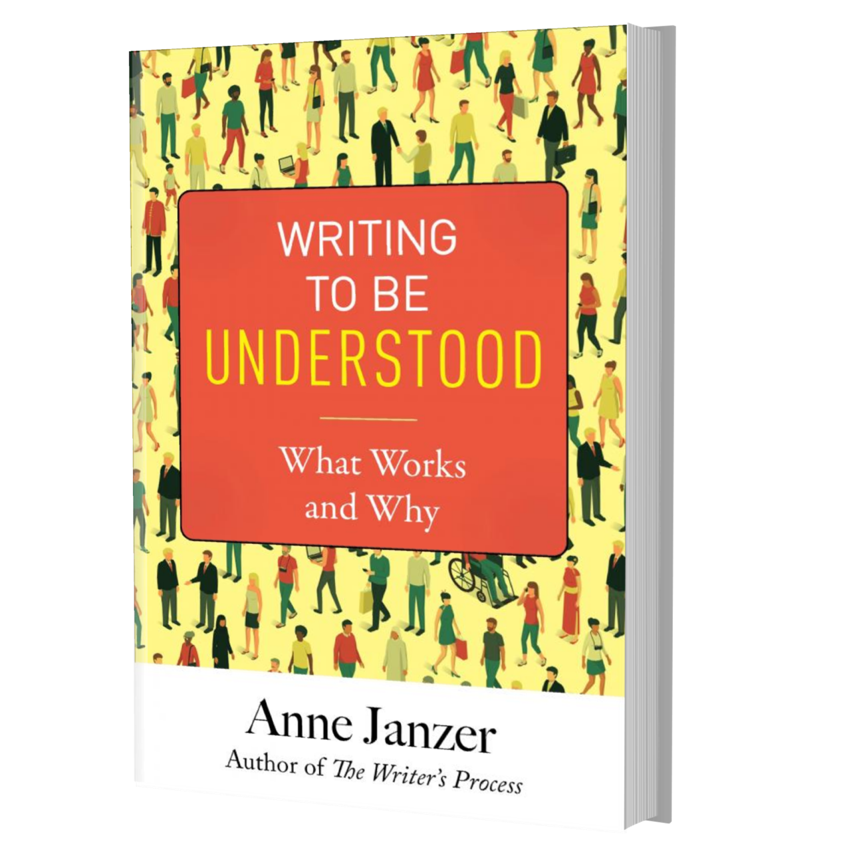

General Questions

Who are your favorite nonfiction authors? Who are the authors you find most effective at explaining complicated topics?

Do you own several nonfiction books from the same author? If so, what is it about that author you enjoy most? The subject? The writing style? Both?

Part One: Understanding Your Reader

Who are your target readers? Can you name or picture a few specific individuals in your core audience?

How interested are they in your subject? Are you writing for people already primed to love your topic, or are you trying to reach a broader audience?

Do you hope to change people’s minds about a topic, to spur them to action, or to teach them something new?

Is there any misinformation floating around the Internet on your subject that would make people question what you write?

Does your topic potentially conflict with your readers’ deeper beliefs, or relate to any of Jonathan Haidt’s moral taste buds (care/harm, fairness/cheating, loyalty/betrayal, authority/subversion, sanctity/degradation, or liberty/oppression)?

Is it possible that you suffer from the Curse of Knowledge when explaining your subject to those not familiar with it? What steps could you take to avoid alleviate the problem?

Part Two: How to Explain Abstract Topics

If your topic is based in abstract reasoning (like physics, mathematics, finance), can you intersperse specific, concrete details in the text?

Do writers in your field commonly use imagery or metaphors? (Think of “the cloud” in technology or “unicorns” in finance.) Do these images help outsiders understand the topic, or have they aged into jargon?

Can you think of a fresh metaphor that provides useful insight for some aspect of your topic?

As a reader, do you find that stories help you remember you remember concepts, or understand them more deeply?

As a writer, do you ever use stories or anecdotes in your own work?

Have you ever changed your mind about a subject after reading a relevant story about it?

How often do you repeat the most important ideas in your writing? Can you reiterate essential that don’t feel repetitive, such as using subheadings, supporting quotes, or illustrative stories?

Part Three: How to Not Be Boring

How would you describe the tone of your favorite nonfiction authors?

How would you describe the tone of your writing: Conversational? Authoritative? Formal? Academic? Is this the tone you want to convey?

Print out a page of your writing and highlight any word or phrase that invokes an image, including verbs with hidden images like trigger. Looking at this list, what emotional content do these images bring with them? Is this the emotional subtext you want to communicate?

Do you need to demonstrate credibility or authority in your writing? If so, how do you do that?

Have you ever read something by an “expert” that you found off-putting, pedantic, or self-important? What did they do that make you felt that way?

Is there a role for humor when writing about your topic? Are you comfortable using humor in your own writing?

What is one writing technique that you will experiment with in the next thing you write?

© 2019 Anne Janzer

